Documentation on Prompting Techniques & Comparative Lang-Chain vs Llama-Index Frameworks

Prompting Engineering

* Prompt engineering is a relatively new discipline for developing and optimizing prompts to efficiently use language models (LMs) for a wide variety of applications and research topics. Prompt engineering skills help to better understand the capabilities and limitations of large language models (LLMs).
* Researchers use prompt engineering to improve the capacity of LLMs on a wide range of common and complex tasks such as question answering and arithmetic reasoning. Developers use prompt engineering to design robust and effective prompting techniques that interface with LLMs and other tools.
* Prompt engineering is not just about designing and developing prompts. It encompasses a wide range of skills and techniques that are useful for interacting and developing with LLMs. It's an important skill to interface, build with, and understand capabilities of LLMs. You can use prompt engineering to improve safety of LLMs and build new capabilities like augmenting LLMs with domain knowledge and external tools.

Elements of a Prompt

* As we cover more and more examples and applications with prompt engineering, you will notice that certain elements make up a prompt.
* A prompt contains any of the following elements:
* **Instruction** - a specific task or instruction you want the model to perform
* **Context**- external information or additional context that can steer the model to better responses
* **Input Data** - the input or question that we are interested to find a response for
* **Output Indicator** - the type or format of the output.

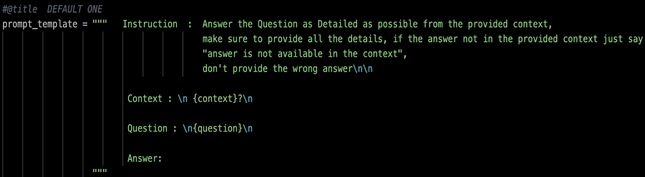Example :

Prompt Techniques

1. **Chain-of-Thought (COT) Prompting**: A prompting technique where the model generates intermediate reasoning steps to reach a conclusion. This helps in solving complex problems by breaking them down into manageable chunks.
2. **Self-Critique**: The model evaluates its own outputs, identifying potential errors or areas of improvement. This self-assessment can be used to refine responses in iterative cycles.
3. **Least-to-Most Prompting**: This method involves starting with simpler prompts and gradually moving to more complex or detailed ones, helping the model build its understanding incrementally.
4. **Step-Back Prompting**: Encourages the model to reassess or reconsider previous steps in the reasoning process to improve the final output, often used when the initial solution isn't satisfactory.
5. **Iterative Prompting**: The process of refining a model’s response through multiple cycles of feedback and adjustment, allowing for incremental improvements in the solution.
6. **Analogical Prompting**: Involves the use of analogies or similar situations to help the model draw parallels and reason through new problems.
7. **Plan-and-Solve Prompting**: The model first formulates a plan to solve a problem and then follows the plan to arrive at a solution, separating the planning and execution phases.
8. **KD-COT (Knowledge Driven COT)**: A variation of Chain-of-Thought where the reasoning process is guided or informed by specific knowledge or external data, enhancing the accuracy and relevance of the output.
9. **COT-SC (Self-Consistency with COT)**: This technique builds on Chain-of-Thought prompting by ensuring that the reasoning steps remain consistent across multiple attempts, leading to more reliable and coherent outputs.
10. **Self-Refinement**: Similar to Self-Refine, this technique emphasizes iterative improvements of the model's output. The model revisits and refines its responses multiple times, enhancing accuracy and depth.
11. **Sequential Prompting**: Involves presenting a series of related prompts in a logical sequence, allowing the model to build on previous responses and develop a more comprehensive solution.
12. **Graph of Thought**: An advanced technique where the model generates and traverses a graph of connected ideas or reasoning paths, allowing for exploration of multiple solutions or perspectives simultaneously.

Lang-Chain vs. Llama-Index Frameworks

Lang-Chain

* **Specialized Library for Complex Applications :** Lang-Chain is designed to simplify and enhance the creation of sophisticated language model applications. It provides tools for chaining multiple prompts.
* **Advanced Development : It** supports a wide range of prompt engineering techniques, reflecting a trend toward more interactive and data-driven AI applications.
* **Modular Architecture :** Lang-Chain's modular design allows developers to plug in different components like prompts, chains, and data connectors, making it easier to customize and optimize language model interactions.
* **Seamless Integration with External APIs :** Lang-Chain supports integration with external APIs, databases, and knowledge graphs, enhancing the ability to perform complex, context-aware operations.

Advantages:

1. **Custom Prompt Programming:** Excels in advanced prompt programming with tailored prompts, integrating complex logic and workflows.
2. Integration with External Tools: Supports external APIs and databases, beneficial for combining data from multiple sources.
3. **Structured Reasoning:** Offers tools for creating structured reasoning approaches, such as graphs and trees.
4. **Memory Management:** Features effective memory management, maintaining context across interactions and refining responses over time.
5. **Iterative Refinement:** Allows for gradual refinement of responses through iterative prompting, useful for developing detailed and accurate outputs.

Disadvantages:

1. **Complex Setup:** Requires a more complex setup and understanding, which can be challenging for users unfamiliar with programming or configuration.
2. **Learning Curve:** The extensive capabilities and customization options result in a steeper learning curve.

Llama-Index

* **Simplified Text Generation:** Llama-Index is designed to simplify text generation with predefined prompt templates, offering a user-friendly interface without needing extensive customization.
* **Versatile Use Cases:** It’s versatile for various text-related tasks, including content creation, summarization, and automated report generation.
* **Ease of Integration:** Designed for easy integration into applications, allowing for quick addition of text generation capabilities.

Advantages:

1. **Ease of Use:** Ideal for users needing simple, effective prompt generation without extensive configuration.
2. **Predefined Templates:** Offers a range of out-of-the-box prompt templates, ideal for common use cases and quick implementations.
3. **General Text Generation:** Performs well in producing coherent and relevant responses for general text generation tasks.

Disadvantages:

1. **Limited Customization:** Offers less flexibility in custom prompt programming and integration with external tools compared to Lang-Chain.
2. **Basic Functionality:** Lacks advanced features like structured reasoning or memory management, better suited for simpler tasks.
3. **Less Advanced Reasoning:** May not support complex reasoning approaches as effectively as Lang-Chain.

Final Recommendations

* Use Lang-Chain for tasks requiring advanced customization, integration with external tools, and complex structured reasoning. It’s ideal for scenarios needing iterative refinement, detailed memory management, and structured workflows.
* Use Llama-Index for simpler text generation tasks where ease of use and predefined prompts are sufficient. It’s effective for straightforward applications and quick implementations without complex configurations.